Saturdaymorning CB
Waterland CB


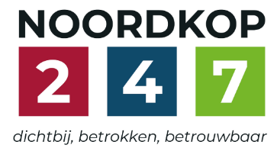
Noordkop Country & Bluegrass

Zaterdag 09:00-12:00: Saturday morning CB
www.Crossroadscountryradio.nl
luisteren kan alleen online via de website.
Herhaling: Donderdag 09:00-12:00
Zondag 19:00-20:00: Waterland CB
https://rtvpurmerend.nl
luisteren online kan via https://rtvpurmerend.nl/radio/live
Dinsdag 22:00-24:00: Noordkop CB
www.regionoordkop.nl
ether: 105.6 en 107.7 FM
luisteren online: www.noordkop247.nl/ live-radio/
Na de uitzending kan het programma worden beluisterd wanneer u maar wilt, via
http://hans.vdveen.org/muziek/
U vindt daar de uitzendingen van het laatste half jaar, waar u vrij uit kunt kiezen.
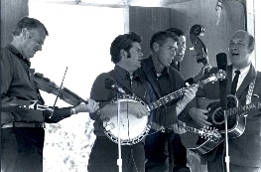

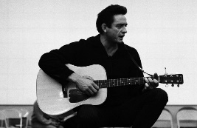
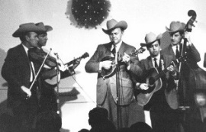
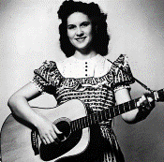
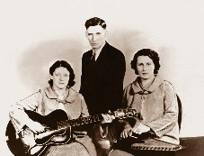
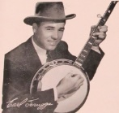
23, 24 & 26 mei 2026
Zondag 19:00-20:00 – Waterland Country & Bluegrass
Dinsdag 22:00-23:00 – Noordkop Country
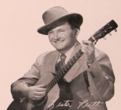
Dinsdag 23:00-24:00 – Noordkop Bluegrass
Zaterdag 09:00-12:00 – Crossroads Radio

samenstelling, montage & presentatie
Hans van der Veen

Speciale aandacht voor het programma van zondag. Wat zou het mooi zijn als mensen als Trump c.s. naar mijn programma’s zouden luisteren en zich iets zouden aantrekken van de adviezen die ik ze af en toe geef. Ik heb geen muziek over Cuba, anders zou ik daar ook een programma voor maken.
Verder kan ik alleen de nieuwe serie melden, zaterdag 10:00. Het worden zeven afleveringen.

Ik wens u weer veel luisterplezier.

Zaterdag 23 mei
Herhaling: donderdag 28 mei
Bij CrossroadsCountryRadio.nl
Saturday morning CB uur 1
09:00-10:00: Country
Beroepen – 8
Truck(driver)s – 5
Country bands & albums 1
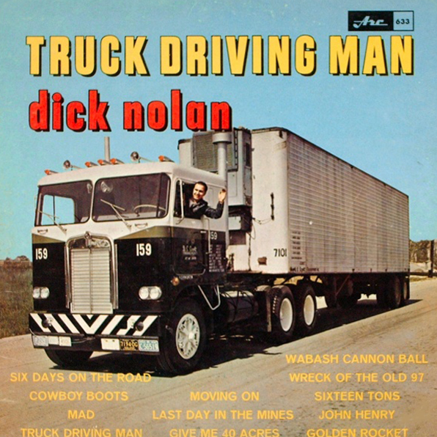

- Broke Down Trucks Trouble
- Drive-By Truckers Little Bonnie
- Truck Stop (Dui) Take it easy, altes Haus
- Truck Stop Rules Hard to Climb
- Bobby MacKey Long night home
- Boxcar Willie How fast them trucks will go
- Calyx Movin’ on
- Commander Cody Diggy Liggy Lo
- Dale Watson Phillip at the station
- Dave Dudley Canadian sunset
- Del Reeves The older the violin the sweeter the music
- Del Reeves Son of a coal man
- Dick Nolan Wabash cannonball
- Donnie Robertson Making you a memory
- Jason Boland Tennessee whiskey
- Jeannie C. Riley One slightly used wedding band
- Kitty Wells What locks the door
- Wolfe Milestone Seasons I’ve spent without you
- Philomena Begley Highwaymen
- Lonesome Vallkey Singers Sneaky Radar
- Jerry Smith I’ll always be in love with you
- Jim Nesbitt Living the life of Riley
Bonus:
- Wink Martindale Giddy up go

Saturday morning CB uur 2
10:00-11:00: Country
De hits en hitjes van 1967
(1) Nummer 1 hits in de USA
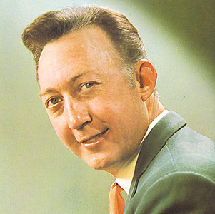
Jack Greene

- Jack Greene There goes my everything
- Loretta Lynn Don’t come home a drinkin’ (with lovin’ on your mind)
- Buck Owens Where does the good times go
- Merle Haggard The fugitive
- Jim Reeves I won’t come in while he’s there
- George Jones Walk through this world with me
- Eddy Arnold Lonely again
- Sonny James Need you
- Buck Owens Sam’s place
- Wynn Stewart It’s such a pretty world today
- Jack Greene All the time
- David Houston With one exception
- Marty Robbins Tonight Carmen
- Sonny James I’ll never find another you
- Merle Haggard Branded man
- Buck Owens Your tender loving care
- David Houston & Tammy Wynette
My elusive dreams
- Leon Ashley Laura
- Eddy Arnold Turn the world around
- Tammy Wynette I don’t wanna play house
- David Houston You mean the world to me
- Sonny James It’s the little things

Saturday morning CB uur 3
11:00-12:00: Bluegrass
Bluegrass Brothers – 2
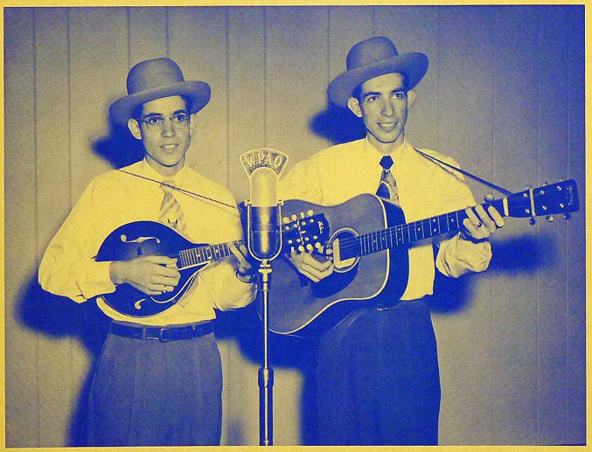
Murphy Brothers

- Hart Brothers Are you missing me
- Blue Sky Boys If you give me your love
- Murphy Brothers You’ll always be my blue eyed darling
- Boyd Brothers Little church back home
- Everett Brothers I just steal away and pray
- Boutilier Brothers Seeing Nellie home
- Brothers 'n Bluegrass Billy McGee
- Gillian Brothers Sally Johnson
- Gillis Brothers Down by the river
- Kay Brothers Be on time
- Smith Brothers BG Orch Rocky top
- Blom Brothers (Zwed) Last train
- Charles Brothers Dark Hollow
- Sauceman Brothers I’ll be no stranger there
- Bibelhauser Brothers Blue collar dreams
- Hodges Brothers Little church house on the hill
- Wilkinson Brothers Light at the end of the darkness
- Morgan Brothers Heartache in my smile
- Looping Brothers (DL) The engineers don’t wave
from the trains anymore

Zondag 24 mei, 19:00-20:00
Bij RTV Purmerend
Waterland CB
Groenland
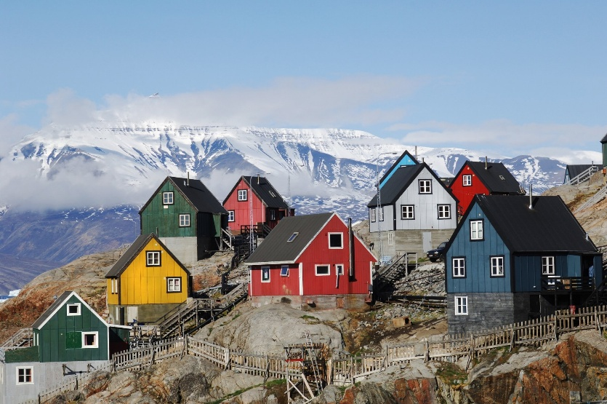

- N Koor uit Nuuk Nunarput
- BG Greenland Station BG Band I know
- C Nive Nielsen (Groenl) Good for you
- F Kitewing The Greenland shark
- F Tamarack The Greenland whales (verkort)
- F Chad Mitchell Trio The ballad of the Greenland whales
- BG Roger Sprung Greenland fisheries
- F Almanac Singers Greenland fishing
- F Peter, Paul & Mary Greenland whale fisheries
- BG Virginia Cut-ups Green country blues
- BG Cliff Waldron Ice covered birches
- BG JD Crowe When the blue grass is covered with snow
- C Bob Dylan Farewell
- BG Flatt & Scruggs Farewell blues
- C Tennessee Ernie Ford Farewell
- BG Lynn Morris Love grown cold
- BG Leon Morris (Can) Drifting with the tide
- C Tommy Cash The tears on Lincoln’s face
- BG Carl Tipton Icy cold
- BG Sam Bush The Icecaps are melting
- BG Doc Watson Below freezing
- N Onbekende Ierse band Greenland is not for sale

Dinsdag 26 mei, 22:00-23:00
Bij Noordkop 247
Noordkop Country
De singles van 1940 en 1970 – 16

Jenny Lou Carson

1940
- Idy Harper The soldier and the lady
- Leon Payne When the sun sets on the Sierra
- Chuck Wagon Gang After the sunrise
- Burl Ives The bold soldier
- Jenny Lou Carson I Married A Mouse Of A Man
1970
- Bobby Lewis Hello Mary Lou
- David Houston Baby, Baby (I Know You're a Lady)
- Loretta Lynn Coal miner’s daughter
- John Williamson (Austr) Old man Emu
- Joni Mitchell Big yellow taxi
- Tex Ritter Green, Green Valley
- Lee Hazlewood No Train To Stockholm
- Lettermen Mr. Lonely
- Rose Maddox Bigger The Pride
- Nitty Gritty Dirt Band The Cure
- Ricky Nelson Down Along The Bayou Country
- Roy Head I'm Not A Fool Anymore
- Justin Tubb The Great River Road Mystery
- Seekers Kumbaya
- Charlie Bailey & Happy Valley Boys
Darling Nellie across the sea
- Wilma Lee & Stoney Cooper Not My Kind
Bonus:
- Currence Brothers Don’t say goodbye if you love me

Dinsdag 26 mei, 23:00-24:00
Bij Noordkop 247
Noordkop Bluegrass
Pop, folk & country songs
door Bluegrass artiesten
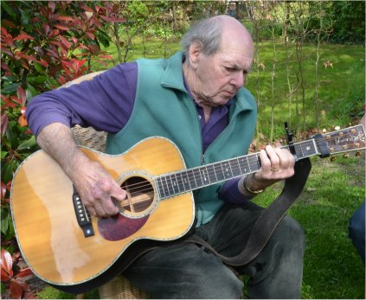
Bill Clifton op leeftijd

- Bill Clifton Beatle crazy
- Jim Bunch Norwegian wood (Beatles)
- IIIrd Tyme Out Only you (Platters)
- Bill Clifton Are you lonesome tonight (Elvis Presley?)
- Charles Hart Are you lonesome tonight
- Alison Krauss I will (Beatles)
- Iron Horse Enter sandman (Metallica)
- Charles River Valley Boys
Beatle medley (Beatles)
- Whitstein Brothers Bridge over troubled water (Simon & Garfunkel)
- Gibson Brothers Crying in the rain (Everly Brothers)
- Doug Dillard Band Heartbreak Hotel (Elvis)
- Bill Evans Lucy in the sky (Beatles)
- Hillbenders – Pinball wizzard (The Who)
- Rob Ickes Can't Find My Way Home (Steve Winwood &
Eric Clapton)
- Country Gentlemen Blowing in the wind (Bob Dylan)
- Dailey & Vincent Class of 57 (Statler Brothers)
- Deanie Richardson In the mood (Glen Miller)
- Gibson Brothers Bye bye love (Everly Brothers)

De vorige week
Wilt u luisteren naar het programma van de vorige week?
Control+klik op onderstaande links

Zaterdag 16 mei, Saturdaymorning Country: Restantje Vrede
https://hans.vdveen.org/muziek/XYZ - CROSSROADS COUNTRY RADIO - Country/507x - Saturday morning Country - 2026-05-16 - Restantje vrede.mp3

Zaterdag 16 mei, Saturdaymorning Bluegrass: Truck(driver)s (4)
https://hans.vdveen.org/muziek/XYZ - CROSSROADS COUNTRY RADIO - Bluegrass/507y - Saturday morning Bluegrass - 2026-05-16 - Truck(driver)s (4, Bluegrass songs 3).mp3

Zaterdag 16 mei, Saturdaymorning Bluegrass: Bluegrass Brothers (1)
https://hans.vdveen.org/muziek/XYZ - CROSSROADS COUNTRY RADIO - Bluegrass/507z - Saturday morning Bluegrass - 2026-05-16 - Brother duets (1).mp3

Zondag 17 mei, Waterland CB: Twee festivals
https://hans.vdveen.org/muziek/W - WATERLAND CB/507w - Waterland CB - 2026-05-17 - Twee festivals.mp3

Dinsdag 19 mei, Noordkop Country: Don’t (1)
https://hans.vdveen.org/muziek/B - NOORDKOP COUNTRY/507b - Noordkop Country - 2026-05-19 - Don't (1).mp3

dinsdag 19 mei, Noordkop Bluegrass: Don’t (2)
https://hans.vdveen.org/muziek/C - NOORDKOP BLUEGRASS/507c - Noordkop Bluegrass - 2026-05-19 - Don't (2).mp3

