Saturdaymorning CB
Waterland CB


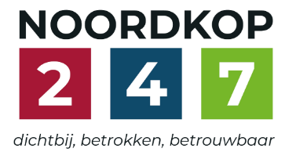
Noordkop Country & Bluegrass

Zaterdag 09:00-12:00: Saturday morning CB
www.Crossroadscountryradio.nl
luisteren kan alleen online via de website.
Herhaling: Donderdag 09:00-12:00
Zondag 19:00-20:00: Waterland CB
https://rtvpurmerend.nl
luisteren online kan via https://rtvpurmerend.nl/radio/live
Dinsdag 22:00-24:00: Noordkop CB
www.regionoordkop.nl
ether: 105.6 en 107.7 FM
luisteren online: www.noordkop247.nl/ live-radio/
Na de uitzending kan het programma worden beluisterd wanneer u maar wilt, via
http://hans.vdveen.org/muziek/
U vindt daar de uitzendingen van het laatste half jaar, waar u vrij uit kunt kiezen.
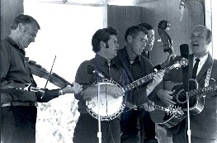

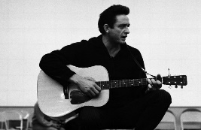
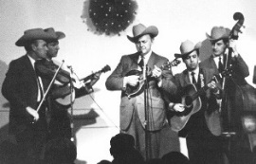
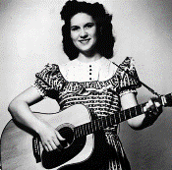
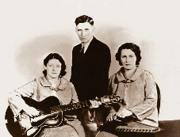
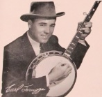
4, 5 & 7 juli 2026
Zondag 19:00-20:00 – Waterland Country & Bluegrass
Dinsdag 22:00-23:00 – Noordkop Country
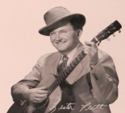
Dinsdag 23:00-24:00 – Noordkop Bluegrass
Zaterdag 09:00-12:00 – Crossroads Radio

samenstelling, montage & presentatie
Hans van der Veen

Ik heb eigenlijk niet zo veel te vertellen. Nou ja, dit: luistert u naar Waterland CB, dan kunt u een vrijkaartje winnen voor het concert van de Stroatklinkers in oktober of van King Springs Road op 30 augustus. Ik verwacht dat het loten wordt.
En over Jim Reeves nog even: opvallend dat hij in Zuid Afrika zo veel navolging vond…..
Ik wens u weer veel luisterplezier!

Zaterdag 4 juli
Herhaling: donderdag 9 juli
Bij CrossroadsCountryRadio.nl
Saturday morning CB uur 1
09:00-10:00: Country
Beroepen – 11
Truck(driver)s – 8
Country songs 3
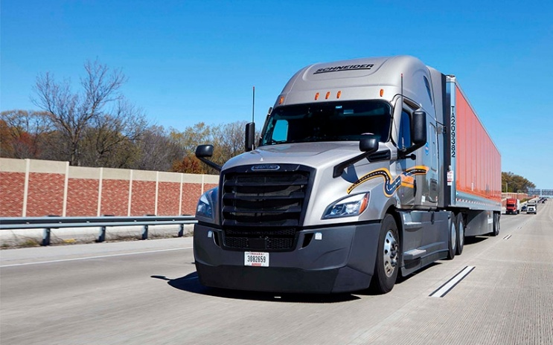

- B.B. Band (Ned) Stille Willie
- Bill Clifton Bringing Mary home
- Red Simpson drugstore truck driver
- Hobo String Band (Ned) Truck Drivin' Cat With Nine Lives
- Philomena Begley (Ierl) Truck Driver’s Sweetheart
- Lee Conway (Austr) Truck drivin’ man
- Bobby Bare The World's Last Truck Drivin' Man
- Shorty Ranger (Austr) Truck Driving Blues
- The Wiggles (Austr) Pickup Truck Driving
- Gram Parsons Drug Store Truck Drivin' Man
- Cartridge Family Stone Vegetarian Truck Driving
Redneck Man
- Steffen Jakobsen (Noorw) Truck Drivin' Son Of A Gun
- Cathy Fink & Marcia Marxer Truck drivin’ woman
- Willis Brothers Truck Driving Sam
- Johnny Chester (Austr) Once I was a truck drivin’ man
- Broken Radio (Duitsl) Tow Truck Driving Lady
- Slim Dusty (Austr) World's Last Truck Drivin' Man
- Charlie Walker Truck Drivin' Cat With Nine Lives
- Buzz Martin Different Kind Of Breed Of A
Truck Drivin Man
- Hank Horton The Life Of A Truck Drivin Man

Saturday morning CB uur 2
10:00-11:00: Country
De hits en hitjes van 1967
3. Hoogstens 2, 3, 4 of 5
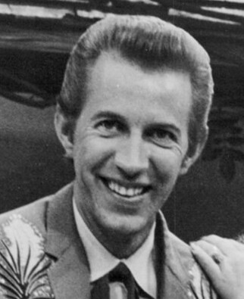
Porter Wagoner

- Jack Greene What Locks the Door
- Porter Wagoner The Cold Hard Facts of Life
- Merle Haggard I Threw Away the Rose
- Johnny Cash and June Carter Jackson
- Billy Walker Bear with Me a Little Longer
- The Wilburn Brothers Hurt Her Once for Me
- David Houston A Loser’s Cathedral
- Eddy Arnold Misty Blue
- Jim Ed Brown Pop a Top
- Tammy Wynette Your Good Girl's Gonna Go Bad
- Charley Pride Does My Ring Hurt Your Finger
- Bonnie Guitar A Woman in Love
- Connie Smith Cincinnati, Ohio
- Warner Mack How Long Will It Take
- Ferlin Husky Once
- Loretta Lynn What Kind of a Girl (Do You Think I Am)
- Connie Smith Burning a Hole in My Mind
- Bill Anderson Get While the Gettin's Good
- George Jones I Can't Get There from Here
- Lynn Anderson If I Kiss You (Will You Go Away)
- Stonewall Jackson Stamp Out Loneliness
- Skeeter Davis What Does It Take (To Keep a Man
Like You Satisfied)
- Liz Anderson Mama Spank

Saturday morning CB uur 3
11:00-12:00: Bluegrass
Bluegrass Brothers – 8
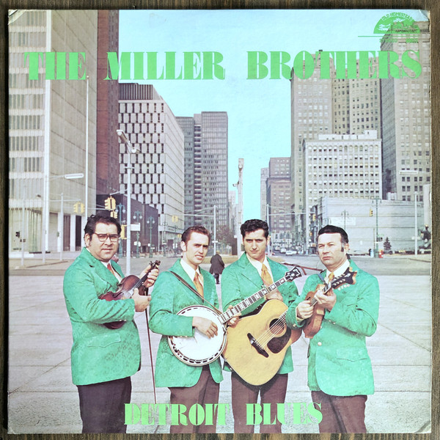
Miller Brothers

- Delaney Brothers Bluegrass Wings of angels
- Goins Brothers Pistol packin’ mama
- Easter Brothers Bible on table
- Moore Brothers Gold watch and chain
- Philyaw Brothers Take me back, little darlin’
- Poteet Brothers Blue grass on the moon
- Eller Brothers & Ross Brown Don’t go riding down that old Texas trail
- Tweedy Brothers Liberty
- Smith Brothers My mother is waiting for me in heaven above
- Sandy Tar Brothers Monkey in the dogcat
- Driver Brothers Goldrush fever
- Mary Lee & The B-Side Brothers
Going hell
- Hawking Brothers (Austr) Linda darling
- Hagan Brothers A girl I once did own
- White Brothers It you’re ever gonna love me
- Pike Brothers Country church
- Long John Brothers Slacker’s breakdown
- McCormick Brothers No substitute will do
- Curley Parker & Garvin Brothers
My guiding star
- Miller Brothers Old Corbin town
- Lilly Brothers I’ll still write your name in the sand

Zondag 5 juli, 19:00-20:00
Bij RTV Purmerend
Waterland CB
Zoek het codewoord
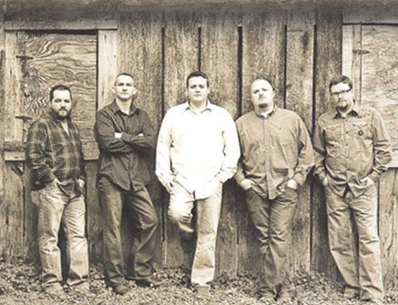
Land of Lincoln

- BG Paul Williams & Cliff Waldron - Another Mile
- BG Uncle Bill & Paul Kelly (Austr) - Gathering storm
- BG Randy Boone & the Gosdin Brothers - It’s all right
- C Mac Davis Rock ’n roll I gave you
- C Earl & Joyce Songer (Can) - Someone to call my own
- C Rick & Thel Carey I wasn’t there
- BG Emma Smith Gradma’s patchwork quilt
- C Ned Miller Lights in the street
- C Dolly, Emmylou & Linda The pain of loving you
- BG Eagle Mountain Boys No alibi
- BG New Lost City Ramblers Old age pension check
- C Wanda Jackson The violet and the rose
- C Arlene Harden He’s a good old boy
- BG Tennessee Bluegrass Band - Letters have no arms
- BG Everett Lilly & Everybody and their brother Waves of the sea
- C Ray Price Burning memories
- BG Land of Lincoln Blue debut
- C Alan Mills The winter of ‘73
- C Nienke Dingemans (Ned) The house of Lily Jones
- BG Don Reno & Red Smiley Seeing Nellie home
Extra
- C Emmylou Harris Drifting to far

Dinsdag 7 juli, 22:00-23:00
Bij Noordkop 247
Noordkop Country
Jim Reeves – 4
Hits en originele opnamen (4)
1963-1965
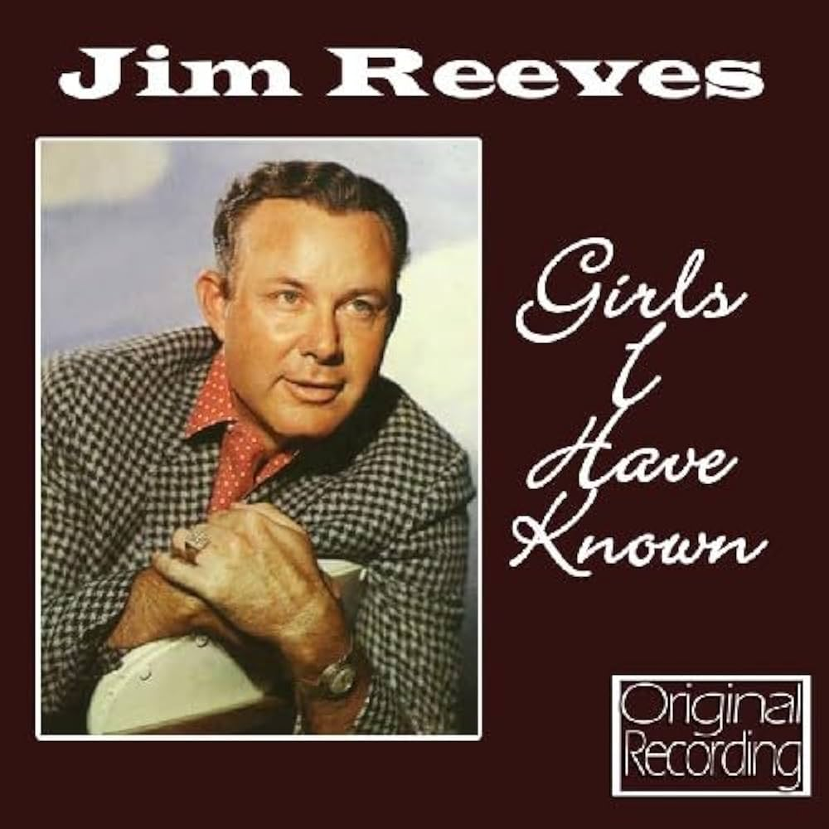
Girls I have know – RCA Victor LPM 1685 - 1958

- Chris Le Roux (Z.Afr.) Daar doer in die bosveld
- Al Grant (Ierl) Golden memories and silver tears
- O.J. Hansen (Noorw) Good morning self
- Ladislav Ridil (Tsj) Znám jeden dum
(I never pass there anymore)
- Foster & Allen Merry Christmas polka
- Jim Tobin Missing angel
- Karel Cernoch (Tsj) Pán buh to Tak Chtel (Senor Santa Claus)
- Rikki Henderson (Eng) There’s a heartache following me
- Tony Wall (Eng) The talking walls
- Hank Cochran You kept me awake last night
- Cindy Walker Blue Canadian Rockies
- John D. Loudermilk Welcome to my world
- Rick Louw (Z.Afr.) A stranger’s just a friend
- The Browns I guess I’m crazy
- Jack Greene & Jeannie Seely Love is no excuse
- Arne Benoni & Heidi Hauge (Noorw)
Look who’s talking
- Daniel O’Donnell Not until the next time
- Freddy Casby (Ned) Rosa Rio
- Loretta Lynn I won’t forget you
- Faron Young This is it
- Al Grant (Ierl) Maureen
Bonus
- Jim Reeves You kept me awake last night
- Jim Reeves Jy is my liefling
- Jim Reeves Draf maar aan ou ryperd

Dinsdag 7 juli, 23:00-24:00
Bij Noordkop 247
Noordkop Bluegrass
Genomineerden voor de
IBMA awards 2001
Banjo, mandoline en gitaar
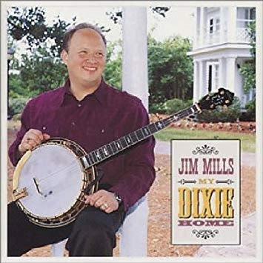

Intro
- Bill Clifton Old cottage home
Banjo
- Tom Adams The village bear
- Alison Brown (met Claire Lynch) Hummingbird
- J.D. Crowe You can be a millionaire
- Jim Mills Take the D-train / Train 45 / Sally
- Sammy Shelor North Carolina breakdown
Mandoline
- Wayne Benson Ole Rowdy
- Sam Bush Eight more miles to Louisville
- Mike Compton Avalon Quickstep
- Ronnie McCoury Our love never dies
- Chris Thile Road to Wrigley
Gitaar
- Jim Hurst This old guitar
- Tony Rice Windy and warm
- Kenny Smith Arkansas traveler
- Bryan Sutton Walking across this land
- Dan Tyminski Wheels
- Tony Rice Go my way
Tenslotte
- Dry Branch Fire Squad Someone to play Dixie for me

De vorige week
Wilt u luisteren naar het programma van de vorige week?
Control+klik op onderstaande links

Zaterdag 27 juni
Saturdaymorning Country: Truck(driver)s (7)
https://hans.vdveen.org/muziek/XYZ - CROSSROADS COUNTRY RADIO - Country/513x - Saturday morning Country - 2026-06-27 - Truck(driver)s (7).mp3

Saturdaymorning Bluegrass: Bruggen (4)
https://hans.vdveen.org/muziek/XYZ - CROSSROADS COUNTRY RADIO - Bluegrass/513y - Saturday morning Bluegrass - 2026-06-27 - Bruggen (4).mp3

Saturdaymorning Bluegrass: Bluegrass Brothers (7)
https://hans.vdveen.org/muziek/XYZ - CROSSROADS COUNTRY RADIO - Bluegrass/513z - Saturday morning Bluegrass - 2026-06-27 - Brothers (7).mp3

Zondag 28 juni
Waterland CB: Boeken (2)
https://hans.vdveen.org/muziek/W - WATERLAND CB/513w - Waterland CB - 2026-06-28 - Boeken (2).mp3

Dinsdag 30 juni
Noordkop Country: 1940 en 1970 (18)
https://hans.vdveen.org/muziek/B - NOORDKOP COUNTRY/513b - Noordkop Country - 2026-06-30 - 1940 en 1970 (18).mp3

Noordkop Bluegrass: Wives (3)
https://hans.vdveen.org/muziek/C - NOORDKOP BLUEGRASS/513c - Noordkop Bluegrass - 2026-06-30 - Wives (3).mp3

